NEW A155 Dis-Eur-Austria-Willendorf-Figurine-Venus-30,000 BP

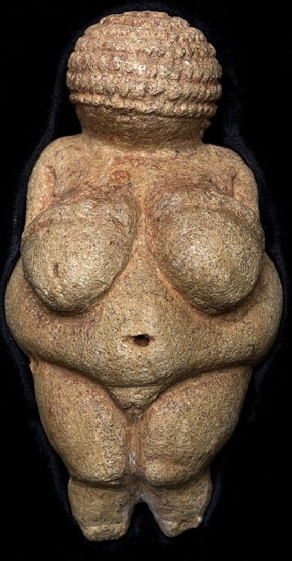

### Fig. 1. The Venus of Willendorf, original in the Naturhistorisches Museum, Vienna

Formal Label: Austria-Willendorf-Figurine-Venus-30,000 BP -27,000 BP

**Display Description:** The Venus of Willendorf (now re-named the “Woman” of Willendorf) is among the most famous archeological finds in the world. It was found in 1908 by a workman named Johann Veran or Josef Veram during excavations conducted by archaeologists Josef Szombathy, Hugo Obermaier and Josef Bayer at a paleolithic site near Willendorf, a village in Lower Austria. It is carved from an oolitic limestone that is not local to the area, and tinted with red ochre. It depicts a corpulent female figure with pendulous breasts, an obese middle and belly, pronounced buttocks, and vulva. The only article of clothing is a braided net that almost totally covers her head. There is no facial detail. Corpulence is presumed rare in the Upper Paleolithic when food was scarce. For reasons to protect childbirth in this challenging climate only this individual’s corpulence was deemed worth ritualizing as a symbol of a successful fertility strategy.

Accession Number: A155

**LC Classification:** GN772.2.A8

Date or Time Horizon: 30,000 BP -27,000 BP

Geographical Area: Aurignacian loess deposit in a terrace about 30 meters above the Danube river near the village of Willendorf in Austria.

**Map, GPS Coordinates:** 48.3166654 15.3833318, 48°18'60.00" N 15°22'59.99" E

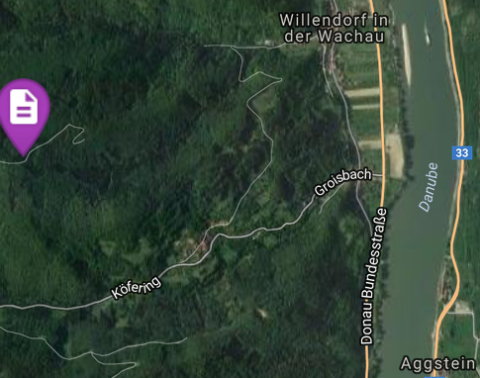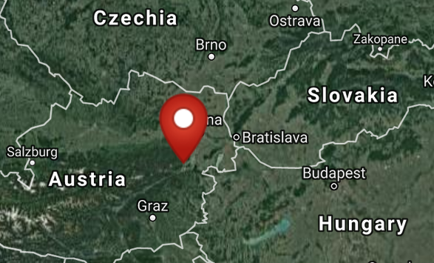

Fig. 2-3. Maps of Willendorf site from http://latitude.to/img/latitude-logo.svg

Cultural Affiliation: Aurignacian of the Upper Paleolithic

Media: yellowish limestone, tinted red by traces of ochre

Dimensions: original, H 11; W 4 cm

Weight:

Condition: original, the feet appear to be broken off. Museum replica in resin.

### Provenance: The Venus of Willendorf was discovered on August 7th, 1908, during excavation work carried out in Willendorf (World Heritage Region, Wachau, Lower Austria) by the Imperial Natural History Museum Vienna by Austrian archaeologist Josef Szombathy during systematic investigations of the local Gravettian settlements in lower Austria, near Krems. Now, in the permanent collection ofrock artin the Naturhistorisches Museum, Vienna.

**Discussion:**

The Venus of Willendorf was created during the same period as several other famous Stone Age figurines, and they perhaps were created also to ritualize a successful fertility strategy. Perhaps the following Gravettian or Upper Perigordian female figurines of the Upper Paleolithic were intended to ritualize a successful fertility strategy also. They include the bas-relief Venus of Laussel (France), the ceramic Venus of Dolni Vestonice (Czech Republic), the ivory Venus of Lespugue (France), the steatite [Venus of Savignano](http://www.visual-arts-cork.com/prehistoric/savignano-venus.htm) (Italy), the stone [Venus of Gagarino](http://www.visual-arts-cork.com/prehistoric/gagarino-venus.htm) (Russia), as well as the Russian ivory figurines, known as the [Avdeevo Venuses](http://www.visual-arts-cork.com/prehistoric/avdeevo-venuses.htm), the [Venus of Kostenky](http://www.visual-arts-cork.com/prehistoric/venus-of-kostenky.htm), the [Mal'ta Venuses](http://www.visual-arts-cork.com/prehistoric/malta-venuses.htm) and the [Zaraysk Venuses](http://www.visual-arts-cork.com/prehistoric/zaraysk-venuses.htm).

**References:**

Angeli, Wilhelm. 1989. *Die Venus von Willendorf*. Vienna: Edition Wein.

Szombathy, Josef. 1915*. Das Versiegen einzelner prähistorischer Kunstepochen und die Stellung der paläolithischen Kunst Mitteleuropas*.

|  |  |  |  |  |
| --- | --- | --- | --- | --- |
|  |  | Vienna: Selbstverl. der Anthropologischen Ges. |  |  |